Welcome To ODM Training

(Docs by – Amulya B Gowda, Kushal Kumar MV, Kiran Kumar BM)

**INTRODUCTION TO IBM-ODM**

ODM means Operational Decision Management. It consists of a set of modules that operate in different environments, but also work together to provide a comprehensive decision management platform.

In ODM there are five main concepts. They are:

1. Rule Designer -> Development.
2. Rule execution server (RES, Decision server) -> It is a server where we deploy our code.
3. Decision center (RTS, Enterprise console) -> It is used to write the business logics.
4. Business console -> User will add and modify the rules.
5. Rule Solution for Office (RSO) -> which provides offline authoring and review features in Microsoft Office document.

*Note: We cannot deploy from Business console.*

Roles of user in ODM

**There are two type of users**.

1. **Business users**

* Business analyst: Bridge between the business side and technical side of a business rule application.
* Policy manager: Business expert and owner of business policy.
* Rule author: Business domain expert who updates and reviews rules.

1. **Technical users**

* Architect: Manages overall deployment, organization of rules and optimization of rules execution.
* Developer: Develops, tests and deploys business rule applications and event application.
* Administrator: Installs and configures rule management and execution environment.

**How to create XOM?**

**XOM**-> Execution Object Model. It references the application objects and data, and is the base implementation of the BOM. It can be a xsd/Java file.

There are two types of XOM

* Java XOM: Java classes
* Dynamic XOM: XML schemas

In the rule designer,

* Click File
* New
* Java Project

**Creating** **XSD**

* Right click on src
* New
* XML Schema (XSD)

**Example:**

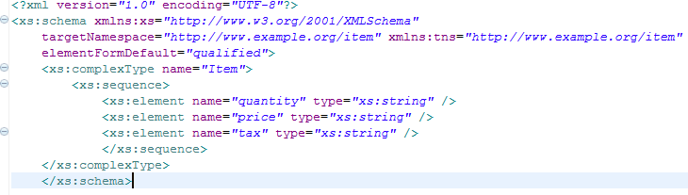

**How to create BOM?**

**BOM**-> Business Object Model. It is the model that defines the entities that are used in business rule artifacts.

Note: BOM is mapped to XOM at run time. All BOM elements that are used in the rules must map to XOM elements.

* Click File
* New
* Rule Project

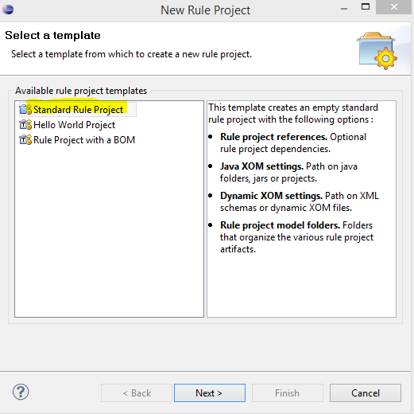

* Click Next
* Give the project name.
* Click next to Rule project references
* If the XOM is in Java then select the Java project and click next.
* If the XOM is XSD then “Add XSD”

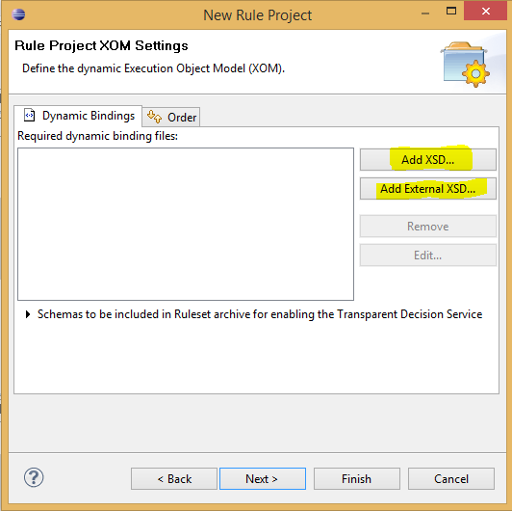

* If the XSD is in local disk then click “Add External XSD”.
* Click Finish.

**Creating BOM entry**

* Right click on “bom”
* New
* BOM entry
* Give the Name
* Select create a BOM entry from a XOM
* Next
* Browse XOM
* Select the project
* Next
* Finish

**Note**: If some changes are made in XOM after creating BOM , to update that changes in BOM, right click on BOM entry and select BOM update. In action click perform and save.

**Defining parameter**

You define input, output, and input/output parameters for rulesets to exchange data with rule applications.

Ruleset parameters provide a mechanism for exchanging data between a ruleset and an application.

Ruleset parameters are defined by the following elements:

* A name
* A BOM type (that is, a class in the business object model)
* A direction:
  + **IN**: The parameter value is provided as input to the ruleset on execution.
  + **OUT**: The parameter value is set by the execution of the ruleset and provided as output from the ruleset at execution completion.
  + **IN_OUT**: The parameter value is provided as input to the ruleset on execution and its value can be modified by the ruleset and provided as output at execution completion.

**Creating Business Rule**

-> It is a statement of business logic that can be understood both by the business users who author the rules, and by the application that calls the rules for execution.

**Types of Business Rule**

* Action Rule
* Decision Table
* Decision Tree

**How to create Action Rule?**

* Right click on rules
* New
* Action Rule

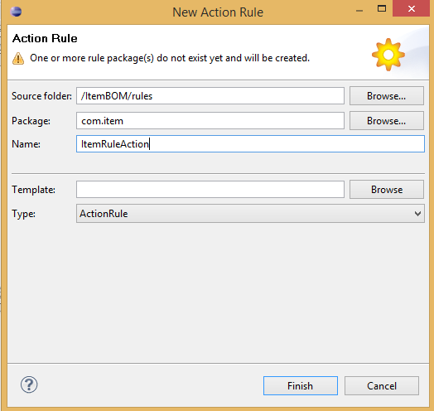

Writing the action rule

**Example**:

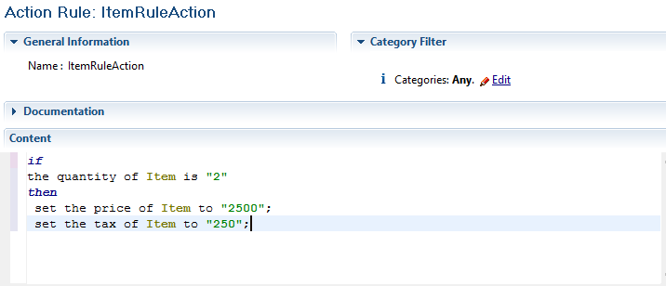

How to create Decision Table?

* Right click on rules.
* New
* Decision table.

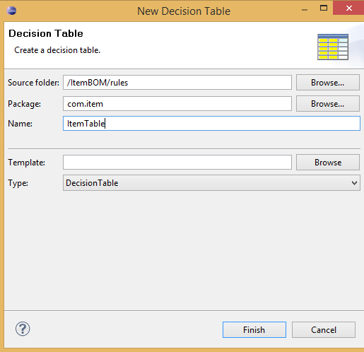

Decision Table contains:

* Condition column.
* Action column.

Writing Condition column

* Right click on column
* Click edit condition column

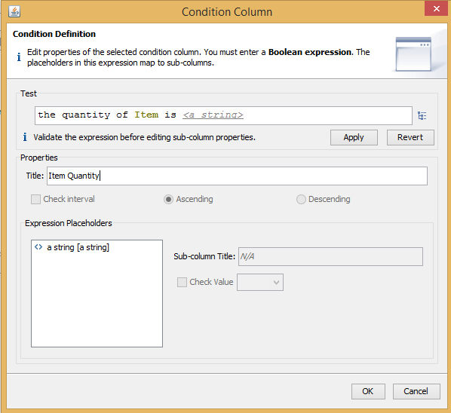

Writing Action column

* Right click on action column
* New
* Click edit action column

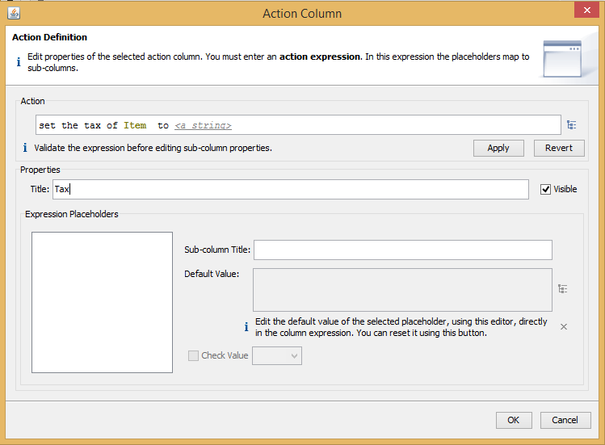

How to create Rule Flow?

* Right click on rules
* New
* Rule Flow

**Example:**

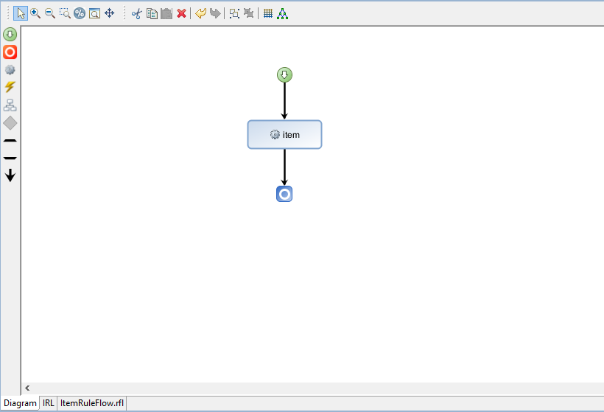

**Initializing subclass**

* Double click on main class in BOM entry
* In members click add
* Select method
* Give the method name
* In type browse void
* Click Finish

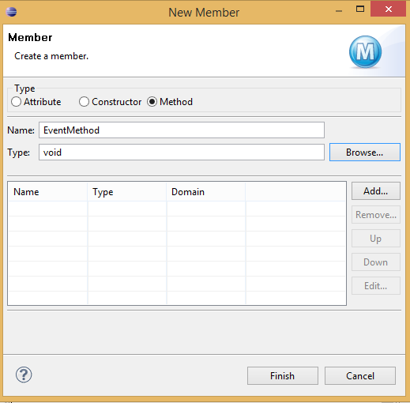

* Double click on that method
* Add arguments
* Select String in type

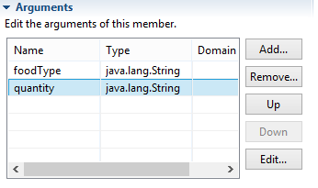

* Create verbalization

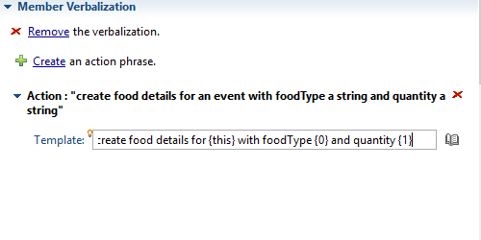

* Write the code in BOM to XOM mapping

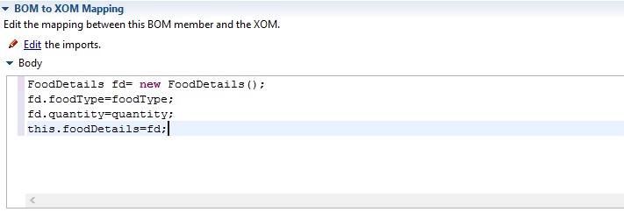

* Save

**Creating Dynamic Domains**

To restrict the values we use domain.

**How to create Dynamic Domain?**

* Create an excel file.

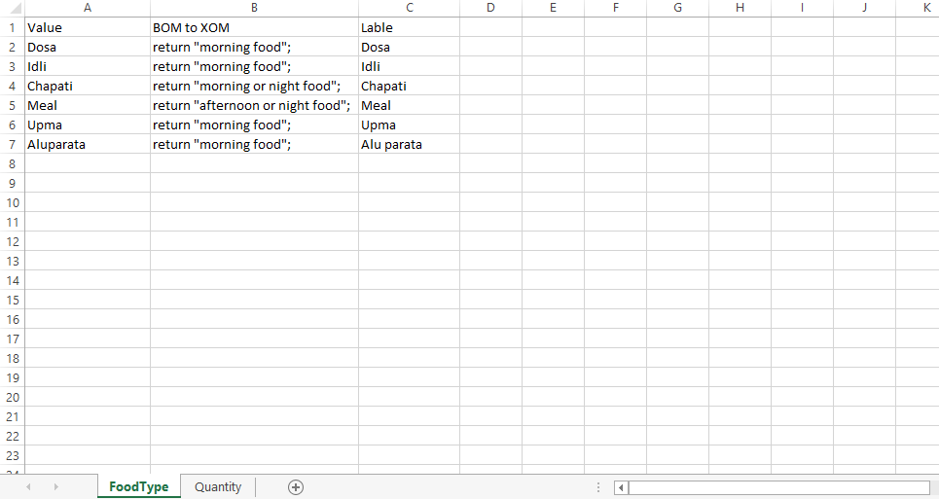

* Copy the excel file.
* Paste it in resources folder in the Rule project.
* Create an empty BOM entry.
* Double click on empty BOM entry.
* Create new packages and classes.
* Create a domain in the new dynamic class.

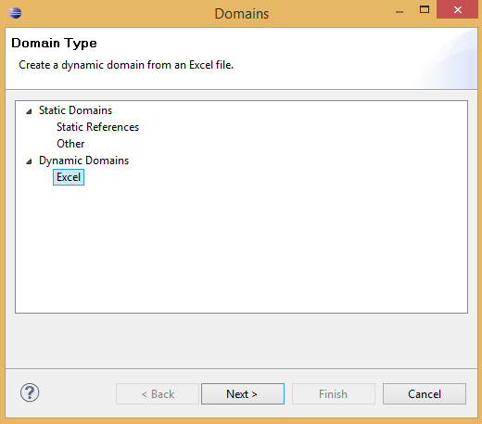

* Select the excel sheet.

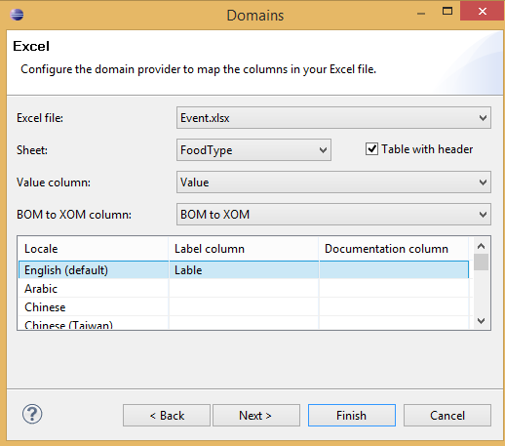

* In BOM to XOM mapping, browse execution name to object.

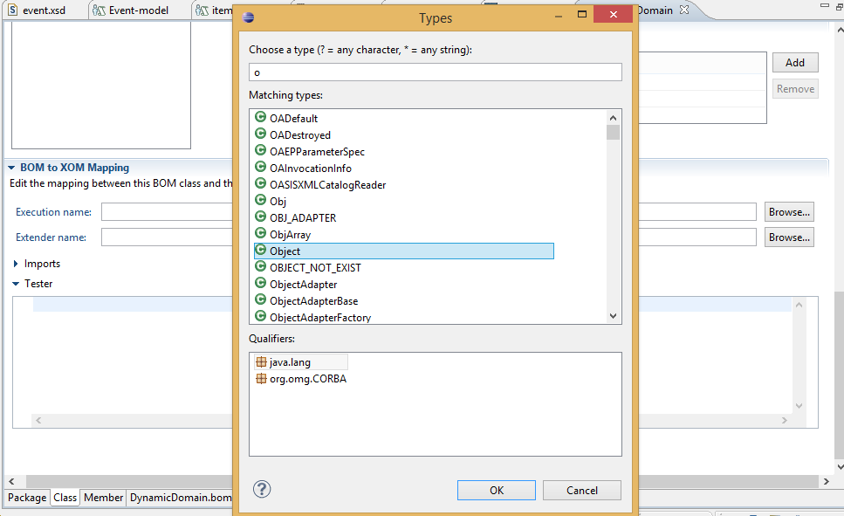

* In the method, change the type of subclasses to the name of the dynamic class.

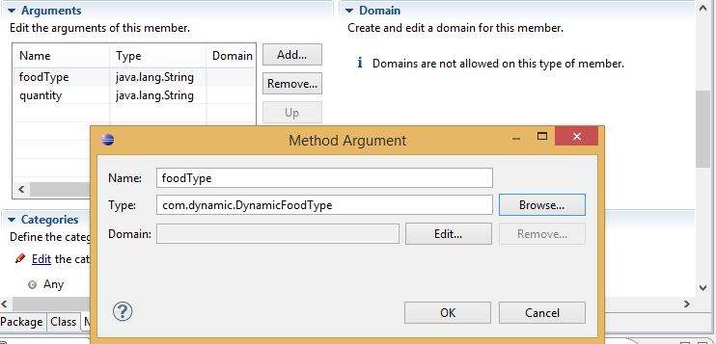

* In BOM to XOM mapping make the following changes:

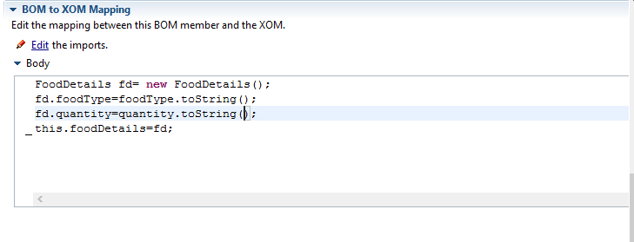

* Save the work.
* Now you will get the drop down values in action column.